Supporting Mental Health & Wellbeing in a Changing World

Access the following services in an emergency or if you need to report an incident.

In An Emergency
Phone: 000
About: Is someone seriously injured or in need of urgent medical help? Is your life or property being threatened? Have you just witnessed a serious accident or crime?
Link: Australian Government Triple zero (000)

Department of Communities and Justice
Phone: 13 21 11
About: Reporting a child at risk. Provides information on child abuse and neglect
Link: NSW Communities & Justice Need help now?

Do you or your child need support with mental health?
You may find the following resources helpful.

Kids Help Line
Phone: 1800 55 1800 Age Group: 5 to 25 years
About: A private and confidential 24/7 phone and online counselling service.
Link: kidshelpline WebChat Counselling
Chat Online: 24/7

Youth Beyond Blue
Phone: 1300 22 4636 Age Group: All ages
About: 24/7 information and support to help everyone in Australia achieve their best possible mental health, wherever they live.
Link: Welcome to Youth BeyondBlue
Chat Online: 3PM - Midnight

1800RESPECT
Phone: 1800 737 732 Age Group: All ages
Interpreter: 13 14 50
About: A confidential information, counselling and support service for people impacted by sexual assault, domestic or family violence and abuse.
Link: 1800RESPECT Online Chat
Chat Online: 24/7

headspace
Phone: N/A Age Group: 12 to 25 years
About: A 24/7 online and telephone support and counselling service for young people, their families and friends.
Link: Welcome to eheadspace
Chat Online: Group chat 24/7, 1-on-1 chat 9AM - 1AM 7 days.

Life Line 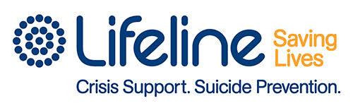
Phone: 13 11 14 Age Group: All ages
Text: 0477 131114
About: A 24/7 crisis support and suicide prevention service.
Link: Lifeline Crisis support chat
Chat Online: 7PM - Midnight Text: 6PM - Midnight

QLife
Phone: 1800 184 527 Age Group: All ages
About: An anonymous and free LGBTI peer support and referral service for people wanting to talk about sexuality, identity, gender, bodies, feelings or relationships.
Link: Qlife Webchat
Chat Online: 3PM - Midnight Phone: 3PM - Midnight

Sane 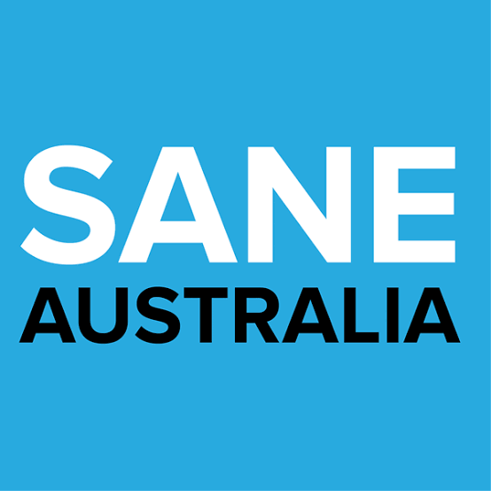
Phone: 1800 187 263 Age Group: All ages
About: Supporting people living with complex mental health issues and the people that care about them.
Link: Sane Australia Phone, Online Counselling & Peer Support
Chat Online: 10AM to 10PM Phone: 10AM to 10PM

Suicide Call Back Service 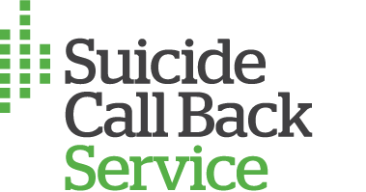
Phone: 1300 659 467 Age Group: All ages
About: A 24/7 nationwide online counselling to people who are affected by suicide, experiencing thoughts of self-harm or suicide.
Link: Suicide Call Back Service Online Counselling
Chat Online & Video: 24/7

Carers NSW
Phone: 1800 242 636 Age Group: All ages
About: Carers Line offers emotional support, referrals and distributes carer specific resources and information to carers and community members.
Link: Carers NSW Australia Carer line
Phone: 9AM to 5PM Monday to Friday

Mental Health Line
Phone: 1800 011 511 Age Group: All ages
About: A mental health professional will answer your call about mental health concerns for you or someone you are concerned about including children, teens, adults and older people.
Link: NSW Health Mental Health Line
Phone: 24/7

If you are seeking additional information.

Black Dog Institute
About: Primary areas of mental health research and treatment include: depression, bipolar disorder, post-traumatic stress disorder (PTSD), anxiety, workplace mental health, adolescents and young people, suicide prevention, e-mental health, and positive psychology and wellbeing.
Link: Black Dog Institute home page

Reach Out
About: Our mission is to deliver innovative e-mental health services that enable young people to take control of their mental health and wellbeing.
Link: Reachout.com home page

The Brave Program
About: BRAVE-ONLINE is an evidence-based cognitive behavioural therapy (CBT) available online to help children (8-12) and teenagers (13-17) cope with anxiety.
Link: BRAVE-Online home page
Smiling Minds 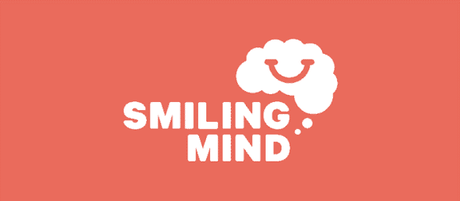
About: Online and app-based program to improve wellbeing of young people through mindfulness meditation.
Link: Smiling Mind home page

If you are looking for an app to support you or your child…

Calm Harm 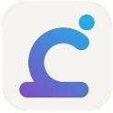
About: Calm Harm provides tasks that help you resist or manage the urge to self-harm. You can add your own tasks too and it's completely private and password protected.
Cost: Free Available: App Store & Google Play

Clear Fear
About: The fear of threat, or anxiety, is like a strong gust of wind. It drags you in and makes you want to fight it or run away. Instead, face your fear with the free Clear Fear app and learn to reduce the physical responses to threat as well as changing thoughts and behaviours and releasing emotions.
Cost: Free Available: App Store & Google Play

ReachOut Worry Time 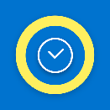
About: ReachOut Worry Time interrupts repetitive thinking by setting aside your worries until later, so you don't get caught up in them and can get on with your day. This means you can deal with worries once a day, rather than carrying them around with you 24/7
Cost: Free Available: App Store

ReachOut Breathe
About: ReachOut Breathe helps you reduce the physical symptoms of stress and anxiety by slowing down your breathing and your heart rate with your iPhone
Cost: Free Available: App Store

Smiling Mind
About: Smiling Mind is a meditation app for young people. It has been developed by a team of psychologists and uses mindfulness to boost calmness, contentment and clarity. Mindfulness meditation has been shown to help manage stress, resilience, anxiety, depression and improve general health and wellbeing.
Cost: Free Available: App Store & Google Play

